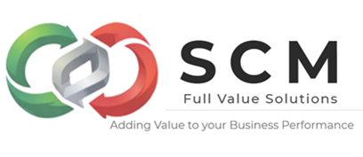
Consulting in operations management is crucial because it helps organizations identify inefficiencies, streamline processes, reduce costs, and improve overall performance, ultimately driving sustainable growth and competitiveness. It provides external expertise, fresh perspectives, and proven methodologies that internal teams may lack.

🔑 Key Importance of Consulting in Operations Management

1. Efficiency and Productivity
- Process optimization: Consultants analyze workflows to eliminate redundancies and bottlenecks.
- Tools and methodologies: Techniques like Six Sigma, Lean, and value stream mapping are applied to boost efficiency.
- Outcome: Faster turnaround times and higher productivity

2. Cost Reduction
- Resource allocation: Consultants help businesses cut unnecessary expenses and optimize resource use.
- Supply chain improvements: Better vendor management and logistics reduce operational costs.
- Outcome: Significant savings without sacrificing quality.

3. Strategic Insights
- External perspective: Consultants bring industry best practices and benchmarking data.
- Decision-making support: They provide actionable recommendations backed by data analysis.
- Outcome: Informed strategies aligned with long-term goals

4. Change Management
- Cultural transformation: Consultants foster a culture of continuous improvement.
- Employee alignment: They help align workforce behavior with organizational objectives.
- Outcome: Smooth adoption of new processes and technologies.

5. Competitive Advantage
- Innovation: Consultants introduce new technologies and digital solutions.
- Agility: Businesses become more adaptable to market changes.
- Outcome: Sustained competitiveness in fast-paced industries.
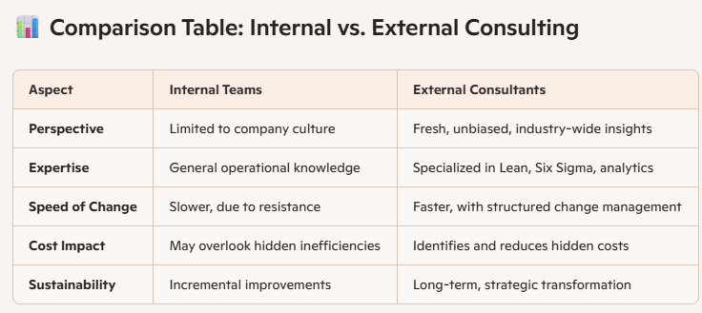

⚠️ Risks and Considerations
- Dependency risk: Over-reliance on consultants can weaken internal problem-solving capacity.
- Cost of consulting: Fees can be high, so ROI must be carefully evaluated.
- Implementation challenges: Recommendations may fail if leadership or employees resist change.

✅ Conclusion
Operations management consulting is not just about fixing inefficiencies—it’s about building resilience and adaptability. For businesses in Mexico and globally, it can mean the difference between stagnation and sustainable growth. The key is to balance external expertise with internal capability-building, ensuring that improvements last beyond the consultant’s engagement.

