
Having trained personnel in operations management is critical because it directly improves efficiency, reduces errors, ensures compliance, and fosters innovation. Well-trained staff can streamline processes, adapt to changes quickly, and contribute to long-term organizational success.

🔑 Why Training Matters in Operations Management

1. Efficiency and Productivity
- Trained personnel understand workflows, tools, and systems, which minimizes downtime and bottlenecks.
- They can identify inefficiencies and propose improvements, leading to faster production cycles and better resource utilization.

2. Quality Control
- Operations staff are responsible for maintaining product and service standards.
- Training equips them with knowledge of quality assurance techniques, reducing defects and customer complaints.

Compliance and Risk Management
- Regulations in industries like manufacturing, healthcare, and logistics are strict.
- Proper training ensures employees follow safety protocols, legal requirements, and ethical standards, reducing liability risks.

4. Adaptability and Innovation
- In fast-changing markets, trained staff can adopt new technologies and methods more easily.
- Continuous development fosters creativity, helping organizations stay competitive.

5. Employee Engagement and Retention
- Training signals investment in employees’ growth, boosting morale and loyalty.
- Skilled workers feel valued, which reduces turnover and recruitment costs.
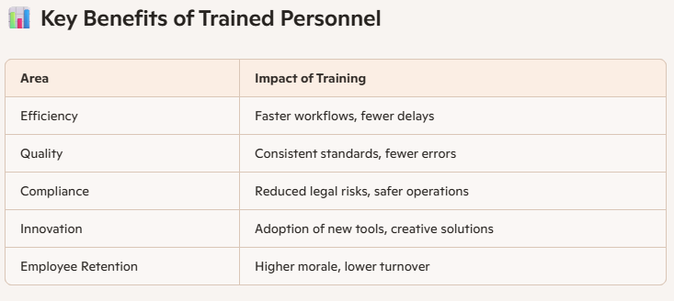

⚠️ Risks of Untrained Personnel
- Operational errors leading to wasted resources.
- Poor customer service damaging brand reputation.
- Non-compliance resulting in fines or shutdowns.
- Low morale and high turnover due to lack of growth opportunities.

✅ Actionable Recommendations
- Conduct regular training needs assessments to identify skill gaps.
- Implement structured training programs (on-the-job, workshops, e-learning).
- Reinforce learning with performance reviews and continuous feedback.
- Encourage cross-training so staff can cover multiple roles during disruptions.

