

Information Technology (IT) is essential because it drives modern economies, enables global communication, supports innovation, and makes everyday life more efficient—from business operations to healthcare, education, and personal convenience. Without IT, productivity, competitiveness, and access to information would be severely limited.

🌐 Key Reasons Why IT Is Important

1. Economic Backbone
- IT underpins nearly every industry, from finance and manufacturing to retail and logistics.
- It enables automation and efficiency, reducing costs and increasing productivity.
- Businesses rely on IT for data management, analytics, and decision-making.

2. Communication & Connectivity
- IT provides instant global communication through email, messaging apps, and video conferencing.
- It bridges cultural and geographic gaps, allowing collaboration across borders.
- Social media and digital platforms connect communities worldwide.

3. Innovation & Competitiveness
- IT enables new business models (e.g., e-commerce, fintech, telemedicine).
- Companies use IT to innovate products and services, staying competitive in fast-changing markets.
- Artificial intelligence, cloud computing, and big data are reshaping industries.

4. Everyday Life Enhancements
- Convenience: Online banking, shopping, and digital payments save time.
- Healthcare: Telemedicine and electronic health records improve access and quality.
- Education: E-learning platforms make knowledge accessible globally.
- Entertainment: Streaming services and gaming rely heavily on IT infrastructure.

📊 Comparison of IT Benefits

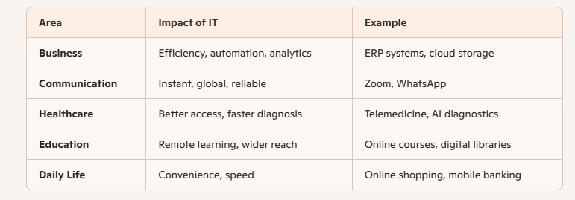

⚠️ Challenges & Risks
- Cybersecurity threats: Data breaches, hacking, and identity theft.
- Digital divide: Unequal access to IT creates social and economic gaps.
- Dependence on technology: Overreliance can lead to vulnerabilities if systems fail.
- Privacy concerns: Personal data collection and surveillance issues.

✅ Takeaway
Information Technology is not just a tool—it’s the foundation of modern society. It empowers individuals, businesses, and governments to operate more effectively, innovate continuously, and connect globally. However, its benefits come with responsibilities: ensuring security, accessibility, and ethical use.

