
Promotional items remain a powerful marketing tool because they create lasting brand visibility, foster customer loyalty, and often lead directly to increased business opportunities. Studies show that more than half of adults regularly use at least one promotional product, and 85% of them eventually do business with the company advertised on it.

🌟 Why Promotional Items Matter

1. Brand Awareness
- Promotional items act as tangible reminders of a company’s brand.
- When customers use or wear these items (pens, tote bags, mugs, T-shirts), they become walking advertisements.
- This visibility extends beyond digital ads, embedding the brand into daily life.

2. Customer Loyalty & Retention
- Receiving a free, useful item creates a positive emotional connection.
- Customers often associate the brand with generosity and reliability.
- This strengthens long-term loyalty and repeat business.

3. Cost-Effective Marketing
- Compared to traditional advertising, promotional products often have a lower cost per impression.
- A single branded pen or reusable bag can generate hundreds of impressions over its lifespan.

4. Business Opportunities
- Over 85% of people who receive promotional items eventually do business with the company.
- Items distributed at trade shows, events, or as corporate gifts often lead to new leads and conversions.
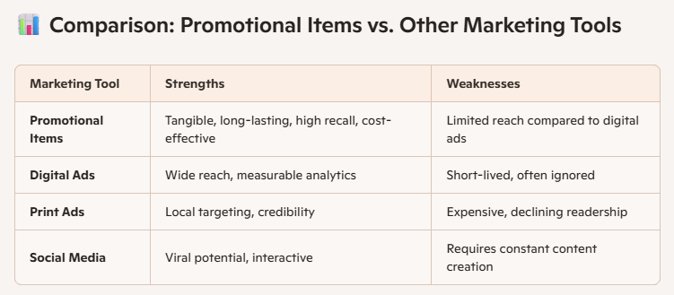

⚠️ Risks & Considerations
- Quality matters: Cheap or poorly made items can harm brand reputation.
- Relevance is key: Items should be useful to the target audience (e.g., reusable water bottles for eco-conscious customers).
- Over-distribution: Giving away too many items without strategy can dilute impact.

✅ Best Practices
- Choose functional items (pens, USB drives, tote bags, mugs).
- Align giveaways with brand values (eco-friendly products for sustainability-focused companies).
- Distribute at high-impact events (trade shows, conferences, community festivals).
- Track ROI by linking promotional items to specific campaigns (QR codes, discount codes).

