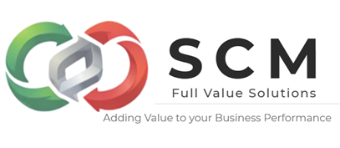
Purchasing is a cornerstone of business success because it ensures cost efficiency, quality, risk management, and smooth operations. A well-managed purchasing process directly impacts profitability, competitiveness, and long-term growth.

🔑 Key Importance of Purchasing
- Cost Savings Strategic purchasing helps businesses negotiate better prices, reduce unnecessary expenses, and optimize budgets. This is especially critical for organizations operating with tight margins.
- Quality Assurance By selecting reliable suppliers, companies maintain consistent product and service quality, which strengthens customer trust and brand reputation.
- Risk Management Purchasing involves evaluating supplier stability, compliance, and reliability. This reduces risks such as late deliveries, poor quality, or financial instability of suppliers.
- Operational Continuity Ensuring uninterrupted supply of materials prevents production delays and service disruptions. Effective purchasing guarantees that businesses always have what they need to operate smoothly.
- Supplier Relationships Strong partnerships with suppliers lead to better deals, improved delivery times, and opportunities for innovation. Long-term collaboration fosters trust and mutual growth.
- Efficiency & Productivity Streamlined purchasing processes—often supported by digital tools—save time, reduce administrative burdens, and allow businesses to focus on growth.
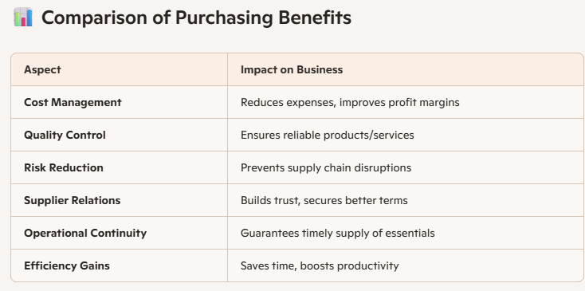

⚠️ Risks if Purchasing is Neglected
- Higher Costs due to poor negotiation or reliance on expensive suppliers.
- Quality Issues leading to customer dissatisfaction.
- Supply Chain Disruptions from unreliable sources.
- Lost Competitiveness if rivals secure better deals and innovations.

✅ Actionable Takeaway
For businesses in Zapopan or anywhere else, investing in strong purchasing management is not optional—it’s strategic. Whether through supplier audits, digital procurement systems, or long-term contracts, effective purchasing ensures stability, growth, and resilience in competitive markets.

En SCM Full Value Solutions lo podemos ayudar a que su empresa añada valor al cliente y valor financiero de forma rentable

