
Reducing inventory is crucial because it lowers costs, frees up warehouse space, minimizes waste, and improves customer satisfaction by aligning stock levels with actual demand. Excess inventory ties up capital, risks obsolescence, and creates inefficiencies in operations.

🔑 Key Benefits of Inventory Reduction
- Cost Savings
  - Lower storage and carrying costs (rent, utilities, insurance).
  - Reduced capital tied up in unsold goods.
  - Less risk of spoilage or obsolescence for perishable or fast-changing products.
- Operational Efficiency
  - Streamlined warehouse management with fewer items to track.
  - Faster order fulfillment and reduced errors.
  - Improved inventory turnover ratio, meaning products move faster through the supply chain.
- Customer Satisfaction
  - Better alignment with demand forecasting prevents stockouts.
  - More reliable delivery times and fewer fulfillment delays.
  - Increased trust and loyalty due to consistent availability of popular items.
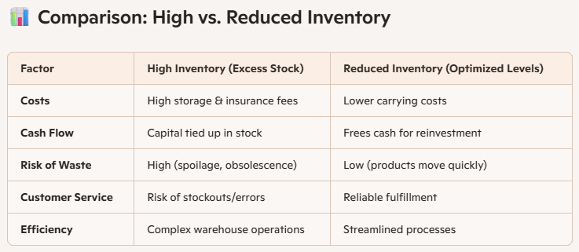

⚠️ Risks & Trade-Offs
- Too much reduction can cause stockouts, leading to lost sales and dissatisfied customers.
- Seasonal businesses (e.g., fashion, holidays) may need buffer stock to handle demand spikes.
- Requires accurate forecasting and strong supplier relationships to avoid disruptions.

✅ Best Practices for Inventory Reduction
- Just-in-Time (JIT) Inventory: Order goods only when needed to minimize storage.
- Regular Audits: Identify slow-moving or obsolete items and liquidate them.
- Demand Forecasting Tools: Use data analytics to predict customer needs.
- Performance Metrics: Track inventory turnover ratio and economic order quantity (EOQ) to optimize levels.

📌 Takeaway
For businesses, inventory reduction is about balance—cutting excess stock to save money and improve efficiency, while maintaining enough to meet customer demand. Done correctly, it strengthens profitability and competitiveness.

En SCM Full Value Solutions lo podemos ayudar a que su empresa añada valor al cliente y valor financiero de forma rentable

