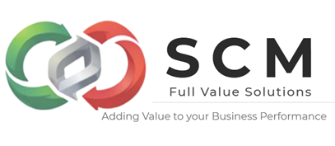
Logistics is the backbone of modern business and global trade, ensuring products move efficiently from origin to customer. Its importance lies in reducing costs, improving customer satisfaction, and enabling competitiveness in increasingly complex supply chains.

🌍 Why Logistics Matters
- Efficient Movement of Goods Logistics ensures that raw materials, components, and finished products are delivered on time and in the right condition, which is critical for both businesses and consumers.
- Cost Optimization In 2024, U.S. businesses spent $2.3 trillion on logistics, highlighting its massive role in operational budgets. Streamlined logistics reduces waste, minimizes storage costs, and optimizes transportation routes.
- Customer Satisfaction Modern commerce depends on logistics to deliver the right product to the right customer at the right time. Fast, reliable delivery builds trust and loyalty.
- Global Trade Enabler Logistics facilitates international trade by managing customs, documentation, and cross-border transportation, making global commerce possible.
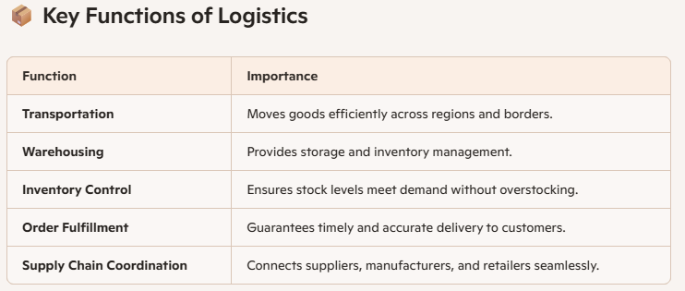

🚀 Benefits for Businesses
- Competitive Advantage: Companies with strong logistics outperform rivals by offering faster, cheaper, and more reliable delivery.
- Scalability: Efficient logistics systems allow businesses to expand into new markets.
- Risk Management: Logistics helps mitigate disruptions (e.g., natural disasters, strikes) by diversifying supply routes.
- Sustainability: Optimized logistics reduces carbon emissions through smarter transportation planning.

⚠️ Challenges & Risks
- Rising Costs: Fuel prices, labor shortages, and global disruptions increase logistics expenses.
- Complexity of Global Supply Chains: Managing multiple suppliers and international regulations can be daunting.
- Technology Dependence: Modern logistics relies heavily on digital tracking and automation, which can be vulnerable to cyberattacks.

📌 Takeaway
Logistics is not just about moving goods—it’s about creating value through efficiency, reliability, and customer satisfaction.

En SCM Full Value Solutions lo podemos ayudar a que su empresa añada valor al cliente y valor financiero de forma rentable

